Student Performance

NAAN MUDHALVAN ARTS INTERNSHIP PROGRAM 2026 PYTHON FOR DATA ANALYTICS PROJECT SUBMISSION TEMPLATE

STUDENT NAME: S.RITHIKA
YEAR: 2024-2027
COLLEGE CODE: MTU 10
COLLEGE NAME: ARULMIGU PALANIANDAVAR ARTS AND SCIENCE COLLEGE FOR WOMEN-ODDANCHATRAM
DEPARTMENT: BSc [Computer Science]
SEMESTER: FIFTH SEMESTER
ROLL NO: 241226ER018
NMID:
TITLE: STUDENT PERFORMANCE & RESULT ANALYTICS
GITHUB LINK : https://github.com/rithu3149-cpu/internship1.git
DATE:23/06/2026

1. ABSTRACT

This project analyzes a Student Performance dataset containing student marks across multiple subjects. The objective is to identify toppers, weak students, pass/fail status, and overall class performance. Python libraries such as Pandas, NumPy, Matplotlib, and Seaborn were used for data cleaning, analysis, and visualization. The dataset was processed to calculate average marks, grades, and subject-wise performance. Various charts and graphs were created to understand trends and compare student results. The analysis helped identify high-performing students, subjects with low average scores, and overall class achievements. The project demonstrates how data analytics can support educational institutions in monitoring academic performance and making data-driven decisions. The final outcome provides clear insights into student achievements and areas needing improvement.

2. PROBLEM STATEMENT

Educational institutions often struggle to monitor and evaluate student performance effectively. Identifying toppers, weak students, and subject-wise trends manually is time-consuming. Data analytics helps automate this process, providing accurate insights into academic performance and supporting better decision-making for students and faculty.

3. OBJECTIVES

- Calculate average marks and grades.

- Determine pass/fail status.

- Identify toppers and weak students.

- Analyze subject-wise performance.

- Create visual dashboards and charts.

- Support data-driven acad
4. PROJECT SCOPE

The project focuses on analyzing student marks using Python and Google Colab. It includes data cleaning, analysis, visualization, and generation of meaningful insights to improve academic monitoring.

5. TECHNOLOGIES USED

- Development Environment: Google Colab

- Programming Language: Python

- Libraries Used:

- Pandas – Data handling and analysis

- NumPy – Numerical calculations

- Matplotlib – Data visualization

- Seaborn – Statistical charts

- Dataset Type: CSV File (Student Performance Dataset)

6. APPLICATION FLOW

1. Load the CSV dataset.

2. Clean missing or incorrect values.

3. Calculate averages and grades.

4. Identify pass/fail status.

5. Perform exploratory data analysis (EDA).

6. Generate charts and visualizations.

7. Interpret results and insights.

8. Prepare final report.

7. KEY PYTHON DATA ANALYTICS CONCEPTS USED

- Data Handling

- Data Cleaning

- Exploratory Data Analysis (EDA)

- Data Visualization

8. EXPECTED OUTPUT

Dataset preview table
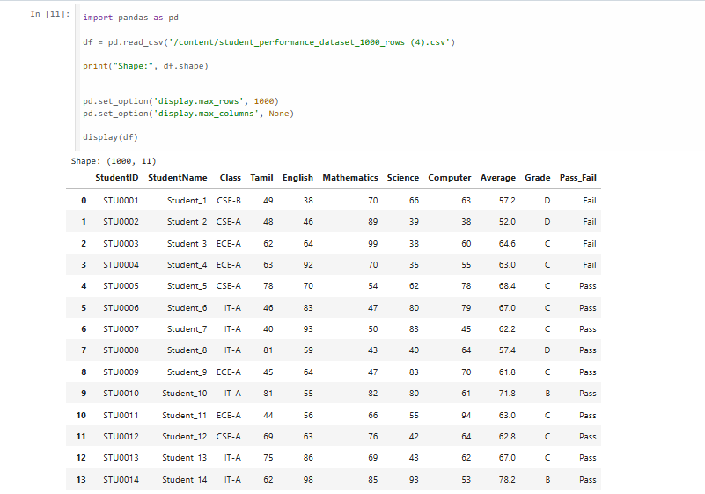

- Cleaned dataset

- Average marks calculation

- Grade distribution chart

- Subject-wise performance chart

- Topper and weak student analysis

- Final insights dashboard

9. CHALLENGES FACED

- Handling missing values in the dataset.

- Ensuring accurate grade calculations.

- Creating meaningful visualizations.

- Managing large datasets efficiently.

- Solution: Data preprocessing techniques and Python libraries were used to resolve these issues.

10. LEARNING OUTCOMES

- Learned Python data analytics concepts.

- Improved skills in Pandas and NumPy.

- Gained experience in data visualization.

- Understood EDA techniques.

- Developed practical knowledge of real-world data analysis projects.

11. CONCLUSION

The Student Performance & Result Analytics project successfully analyzed student academic data and generated meaningful insights. The project helped identify toppers, weak students, and subject-wise trends. Through Python-based data analysis and visualization, academic performance was evaluated efficiently, supporting better educatiocnal decision-making and demonstrating the value of data analytics in education.

GITHUB LINK : https://github.com/rithu3149-cpu/internship1.git

